LAB Workshop 2020
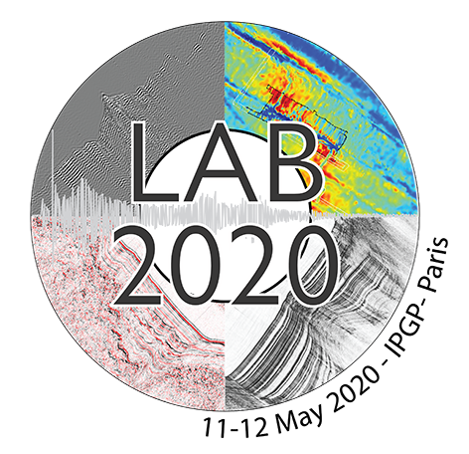

WHEN: May 11-12, 2020
WHERE: IPGP Amphitheatre,
1 rue Jussieu,
75238 Paris Cedex 05,
France

Abstract submission form

Please fill in the form and send it back to the following address along with your abstract at LABworkshop2020@gmail.com

Guidelines: your file should contain a title, the list of all co-authors with their affiliation, and the summary of max. 500 words including references if needed. Images are not accepted.
If the first author is not presenting, thanks for indicating the presenter

Email address
Email:

Last Name
Name:

First name
Name:

Preferred presentation format?
(Oral, poster, oral or poster)

Thank you!

