LAB Workshop 2020
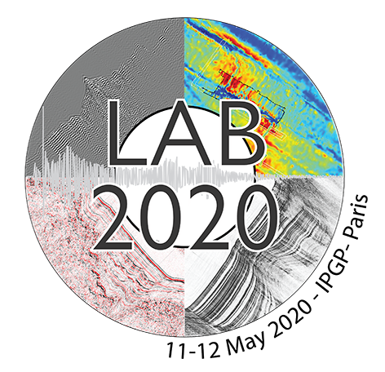

WHEN: May 11-12, 2020
WHERE: IPGP Amphitheatre,
1 rue Jussieu,
75238 Paris Cedex 05,
France
Registration form

Please fill in the form and send it back to the following address at LABworkshop2020@gmail.com

Email address
Email:

Last Name
Name:

First name
Name:

Insitution/Affiliation
Name:

Attendance
11th (yes/no):
12th (yes/no):

Invitation letter (If you need an invitation letter, please provide the following information)
Full name (as in passport):
Passport number:
Citizenship:
Date of Birth (DD/MM/YYYY):

Food preference (Let us know if you have any allergy as well)
(Vegetarian, vegan, no gluten, other):

Will you attend the conference dinner on the 11th of May?
(yes/no):

Thank you!

